**PROJECT REVIEW**

|  |  |
| --- | --- |
| Date | 22 oct 2023 |
| NM ID | 2528AD5D5FF8201AD214F41476392A40 |
| Project Name | How to submit your website’s sitemap to Google  Search Console |

**INTRODUCTION**

**Project overview:**

In the vast landscape of the internet, having a website is just the beginning of your online journey. The true challenge lies in ensuring that your website is discoverable and accessible to your target audience. This is where search engines like Google play a pivotal role, serving as the primary gateway for users to find and access your web content.

To make your website visible and rank well in Google's search results, you need to provide the search engine with essential information about your site's structure and content. One effective way to achieve this is by submitting your website's sitemap to Google Search Console.

A sitemap is essentially a roadmap for search engine bots, outlining the various pages and content on your website. By submitting your sitemap to Google, you're telling it, "Here's where everything is, please crawl and index these pages." This step is a fundamental component of Search Engine Optimization (SEO) and an essential practice for website owners and administrators.

In this comprehensive guide, we will walk you through the process of submitting your website's sitemap to Google Search Console, step by step. Whether you're a seasoned webmaster or a newcomer to the world of website management, this guide will provide you with the knowledge and tools needed to improve your website's visibility in Google's search results. We'll cover everything from creating your sitemap to verification and monitoring, helping you take control of your website's online destiny.

By the end of this guide, you'll be well-equipped to ensure that your website is effectively indexed and appears where it matters most - in front of your target audience in Google's search results. Let's begin the journey to enhanced online visibility and search engine success.

**Purpose:**

Improved Indexing: By providing Google with a comprehensive sitemap, you make it easier for search engine bots to discover and index your website's pages. This ensures that your content is included in Google's database and can appear in search results when relevant queries are made.

Better Ranking Opportunities: With an indexed sitemap, Google can accurately assess the relevance and quality of your website's content. This can lead to improved search engine rankings, making your site more likely to appear on the first page of search results, which significantly impacts the visibility of your website.

Enhanced User Experience: When your website is effectively indexed, users can find your content more easily. This improves the user experience and increases the likelihood of visitors engaging with your website, consuming your content, and potentially converting into customers or subscribers.

Visibility to a Wider Audience: Submitting your sitemap ensures that your website is visible not only to users actively searching for your content but also to a wider audience that may discover your site indirectly through related queries.

**LITRATURE SURVEY**

**Provide Context:**

Literature surveys set the context for your research by summarizing existing knowledge on the topic. They help readers understand the current state of the field.

**Identify Gaps:**

By examining the literature, you can identify gaps or areas where more research is needed. This helps you define the scope and objectives of your study.

**Justify Research:**

A well-constructed literature review justifies the importance of your research and demonstrates that it contributes to the existing body of knowledge.

**Evaluate Methodologies:**

You can assess the methodologies and approaches used in previous research to inform your own research design.

**Synthesize Findings:**

A literature survey synthesizes and organizes the findings of various studies, making it easier for readers to grasp the overall trends and patterns in the field.

**Step 1:Search Google Console**

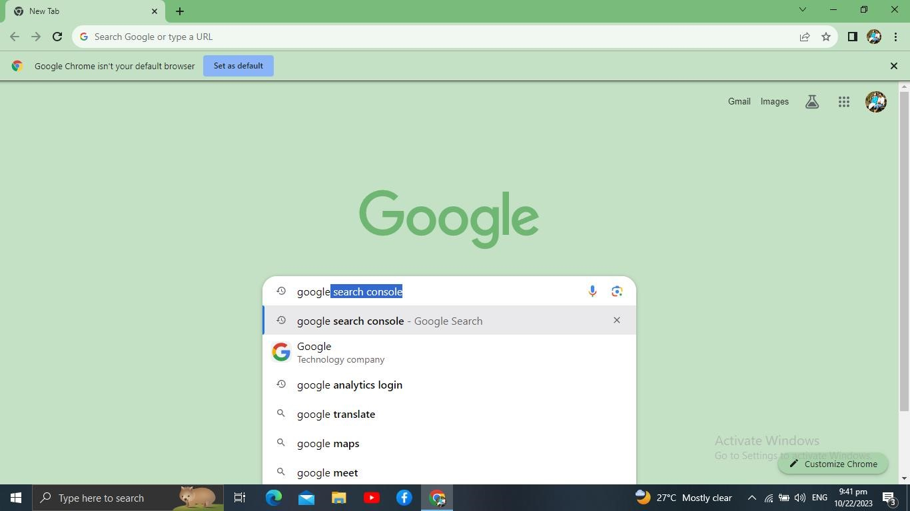

**Step 2: Click Google Search Console Tools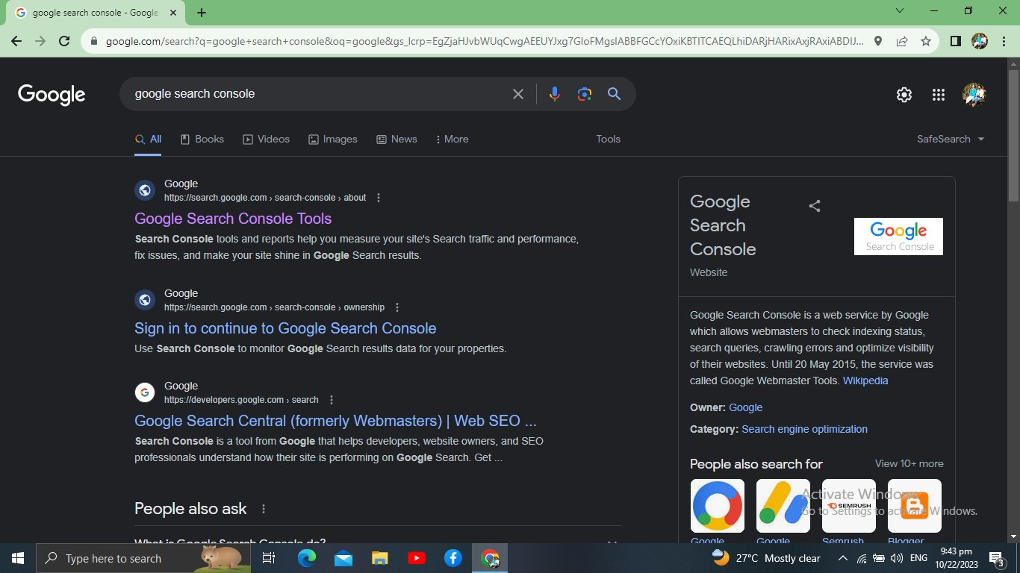Sept 3; Click Start Now 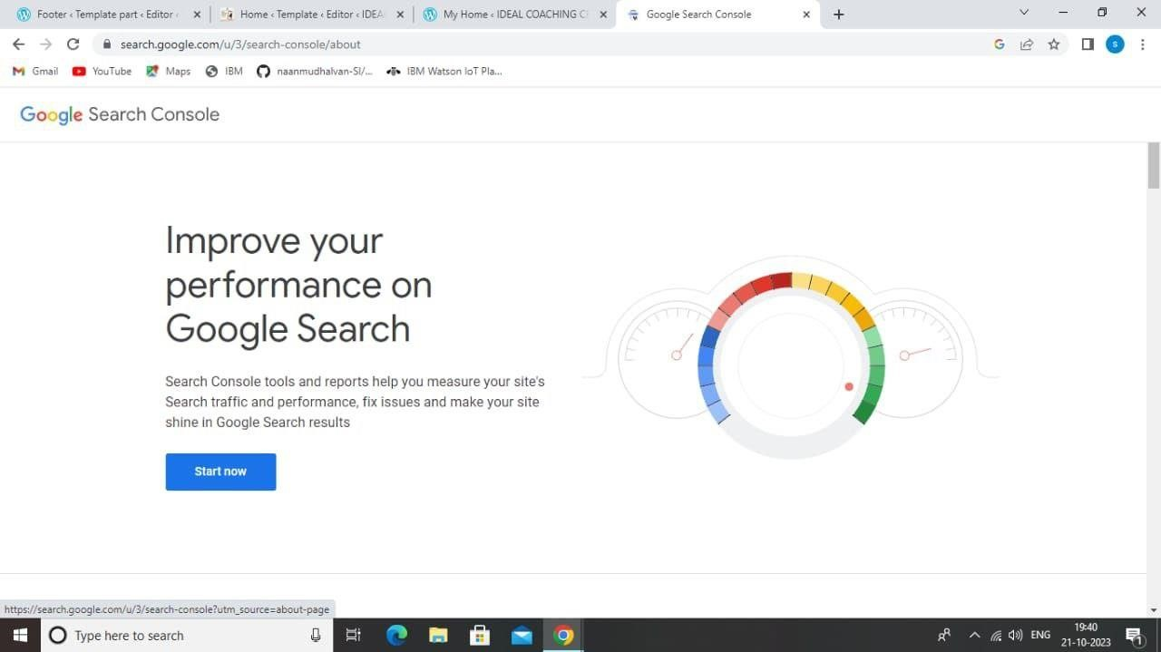Sept 4;** **Add Your Property 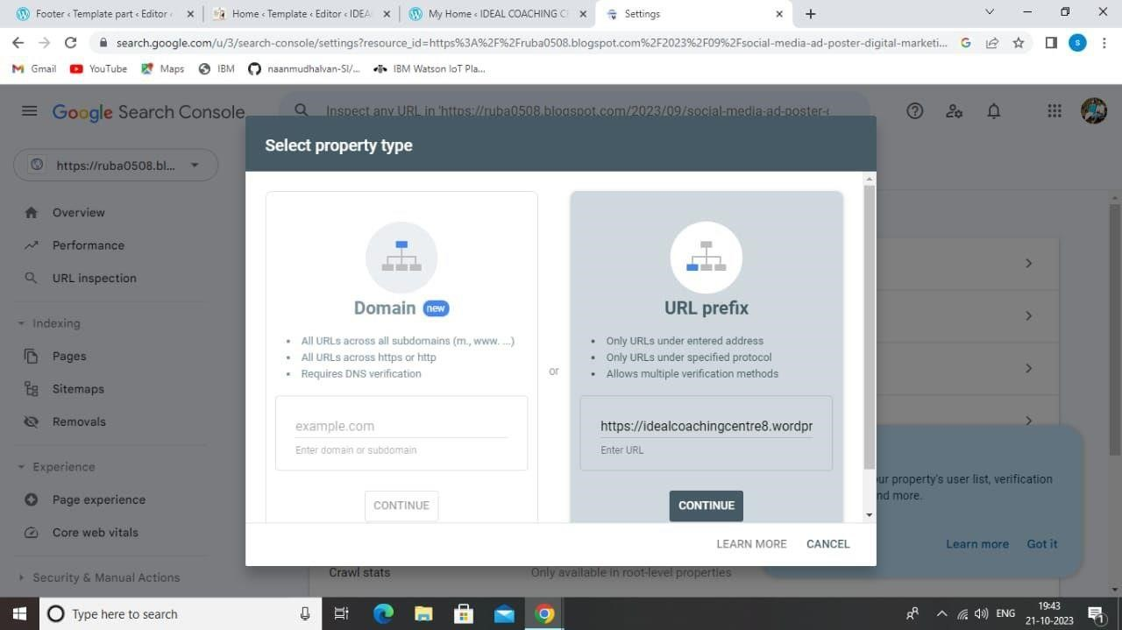Sept 5;Verify Ownership 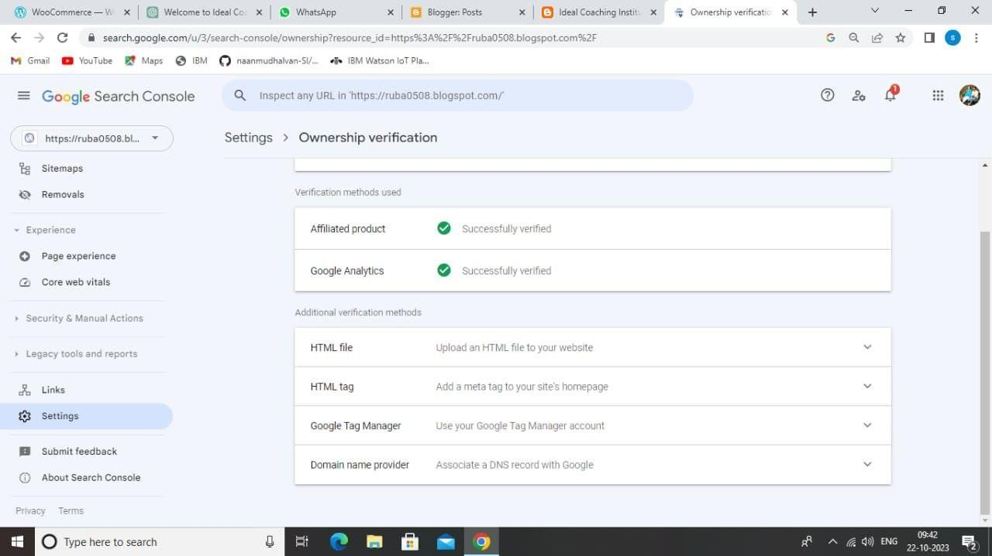Sept 5;Add a New Sitemap and Enter Your Sitemap URL 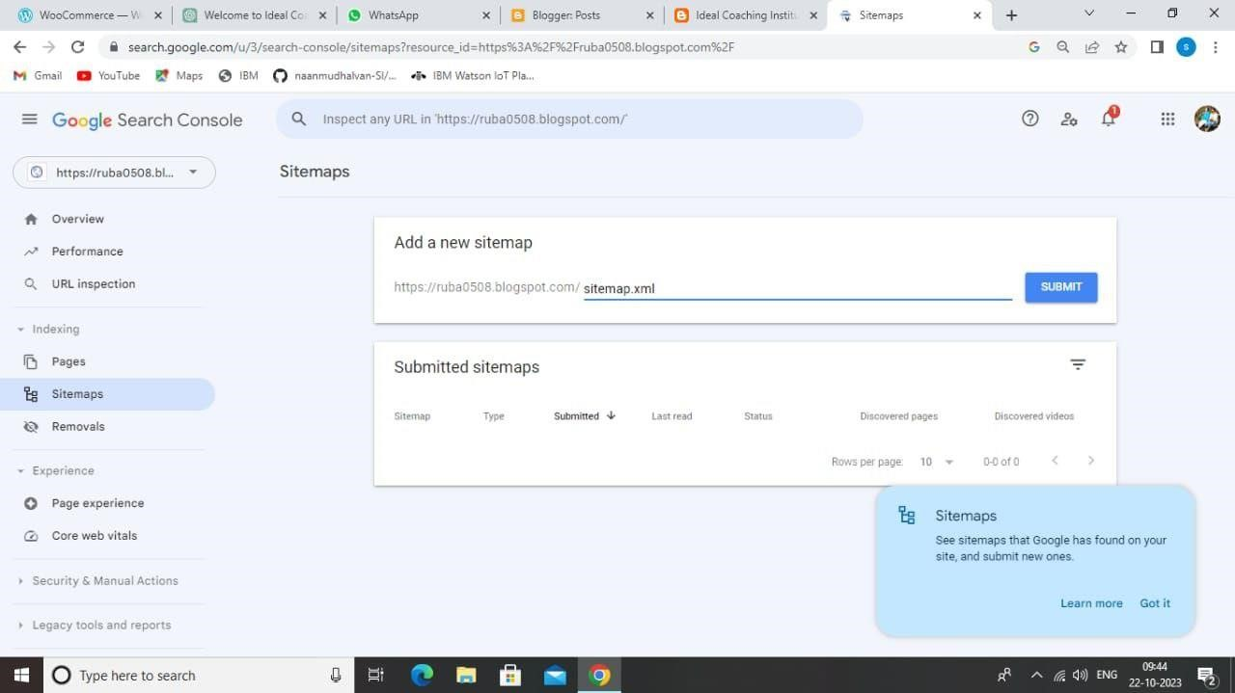Sept 6;Click Status** 